**Exercise 01 (Go throught the practice exercises, and understand them)**

Go throught Practice 3, 4, 5, 6 and 7. Understand these exercises and run them in devc.

Now you need to run each exercise atleast two times with different inputs. (try to put invalid

data to see how the program deals with that data). Add screenshots for each ecercise.

(Just put the practice exercise number and the screenshots of output).

**Practice Exercise.3**

**Valid Input**

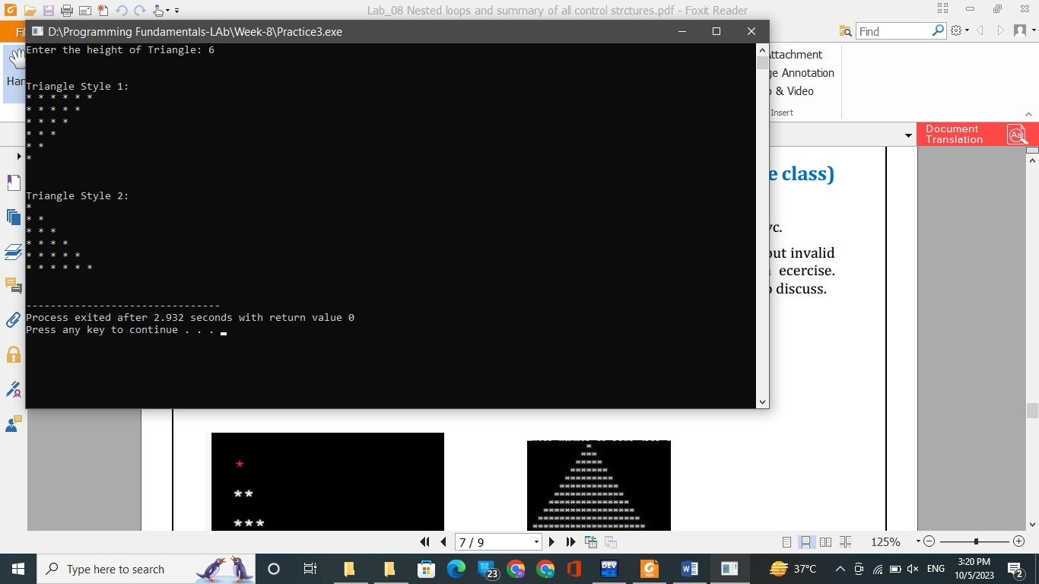

**Invalid Input**

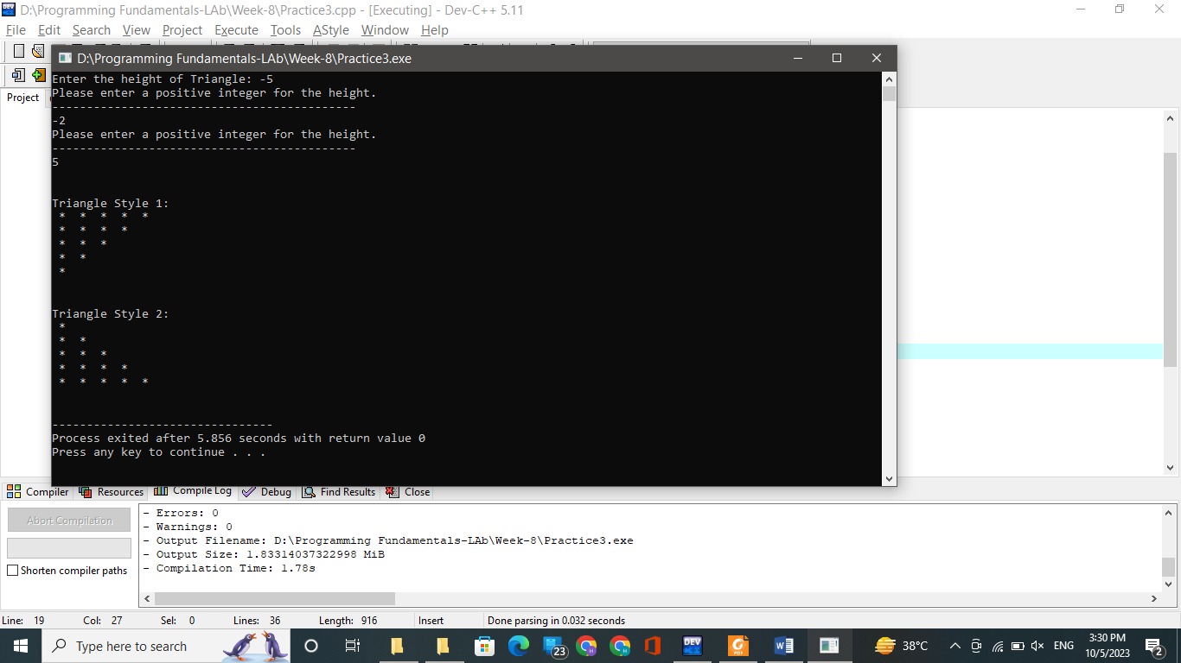

**Practice Exercise.4**

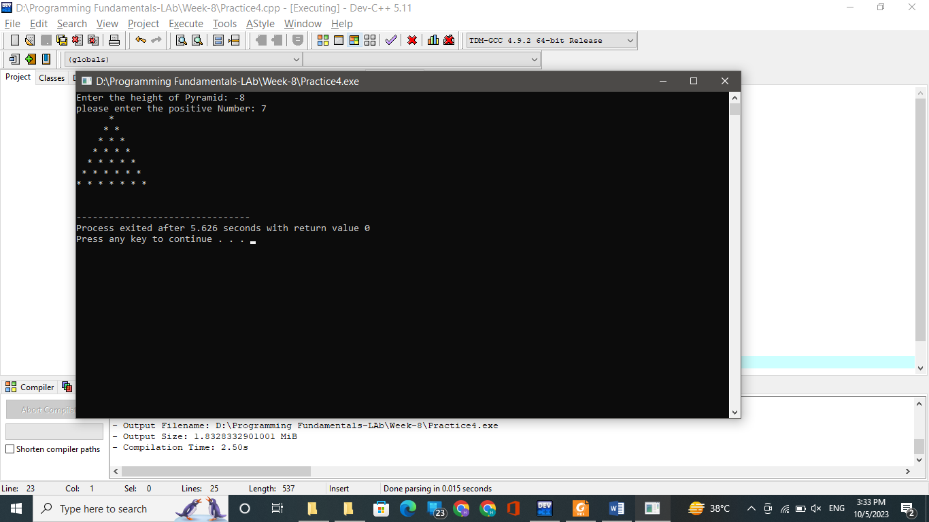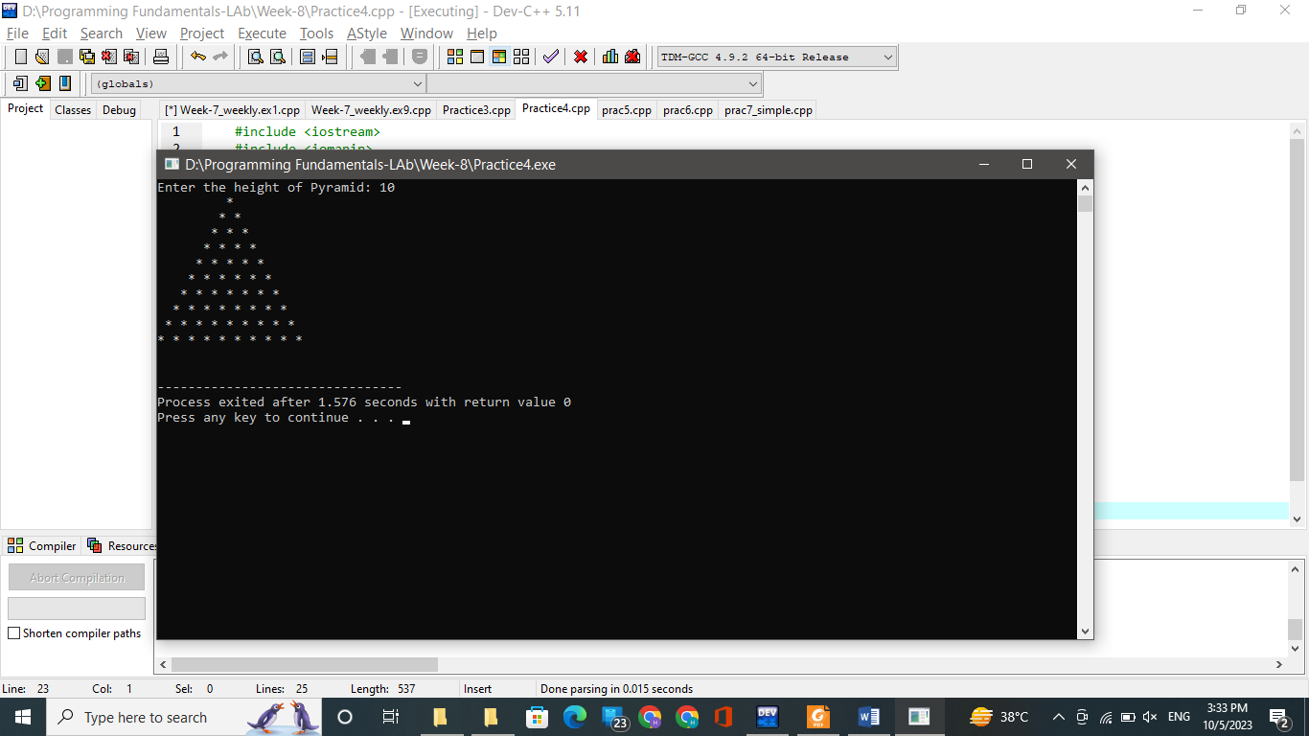**Valid Input: Invalid Input:**

**Practice Exercise.5**

**Valid Input:**

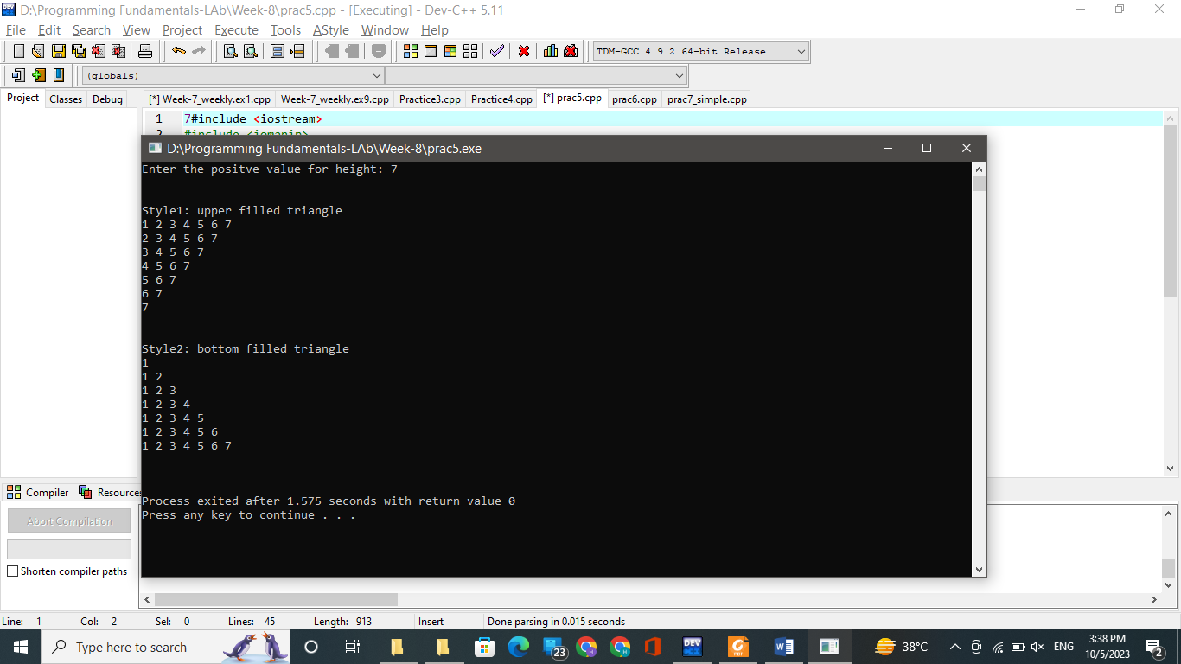

**Invalid Input:**



**Practice Exercise.5**

**Valid Input:**



**Invalid Input:**

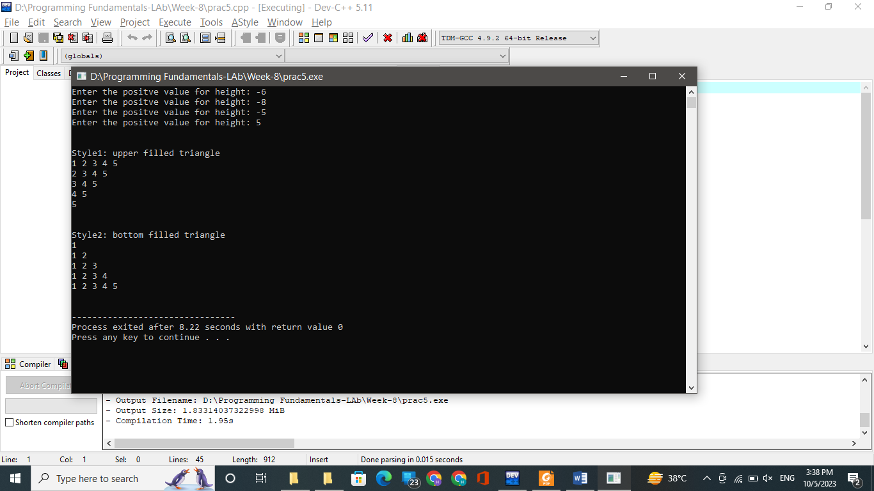

**Practice Exercise.6**

**Valid Input:**



**Invalid Input:**



**Practice Exercise.7**

**Valid Input:**

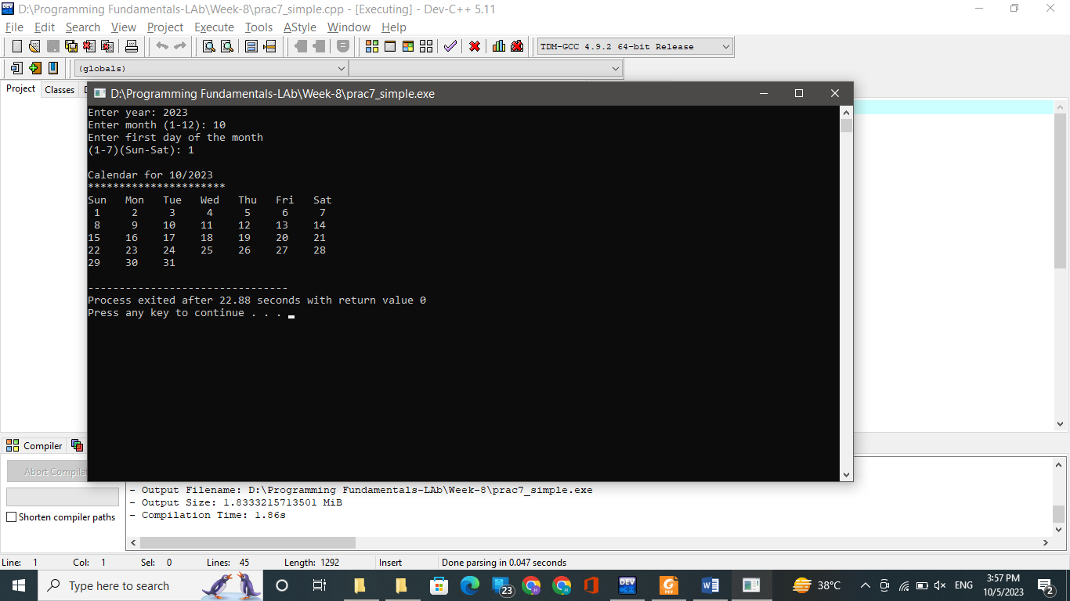

**Invalid Input:**

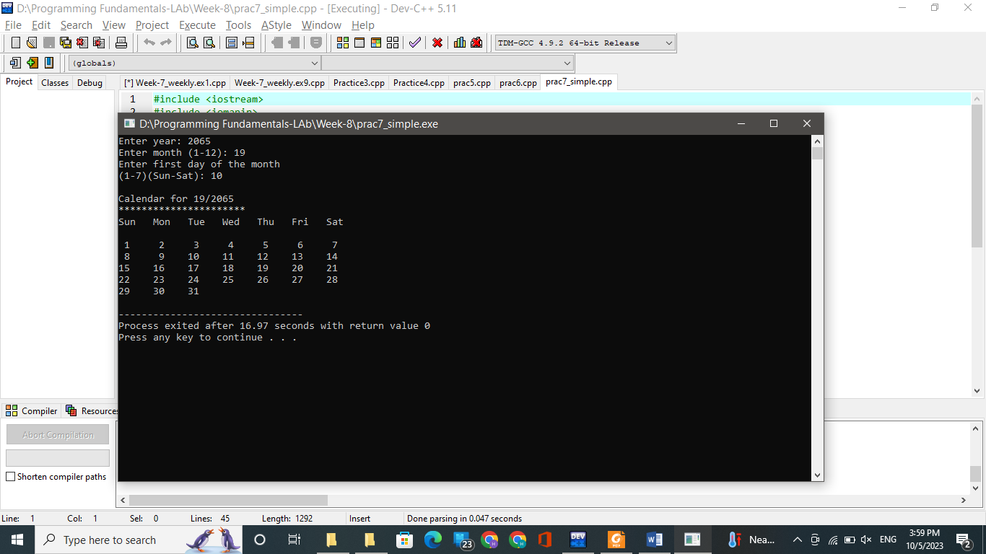

Exercise 02 (Shapes)

**(A)**

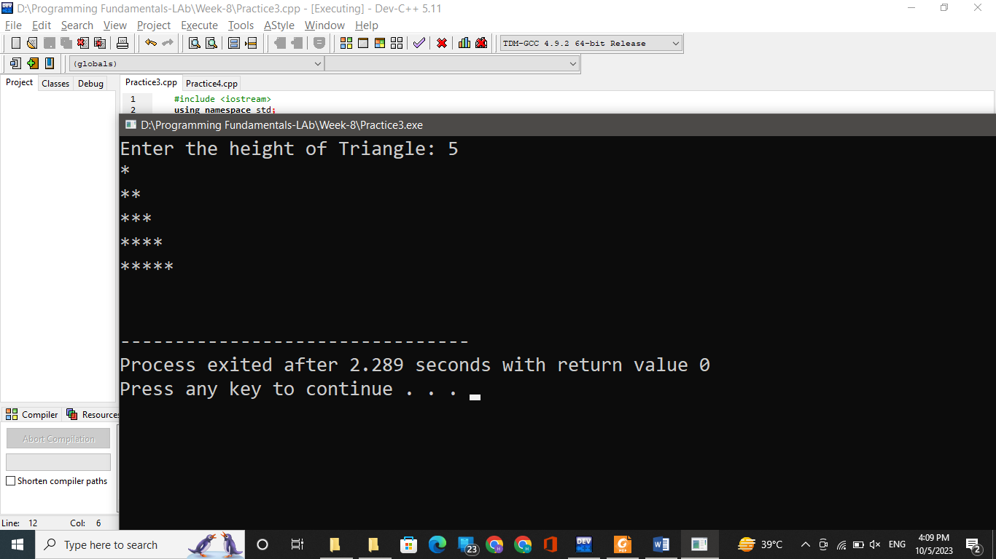

**(B)**

**Exercise 03 (Print the shapes with user input)**

Ask the user to input the height of the diamond then print the diamond as shown.

Also, make sure the height is positive odd number and is greater than or equal to 3 (>=3)

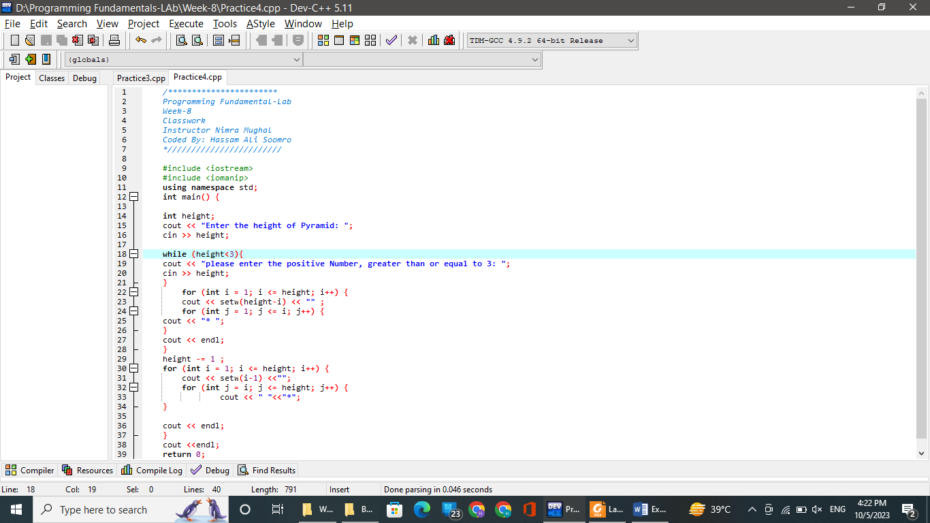



Exercise 04 (GRADE CALCULATION and input validation)  
Write a program to ask user input n_courses (Total Courses), then iterate loop n_coursestime and ask the user marks in each course and perform following tasks:  
a) Make sure the n_courses is between (4-7, Give warning message to user and  
input again)  
b) Make sure the input marks are in the range of (0-50, Give warning message to  
user and input again)  
c) Calculate the average of all course marks.  
d) Calculate the total percentage of all courses.  
e) Tell the user whether s/he is PASS/FAIL, FAIL → less than 60, and  
otherwise PASS.



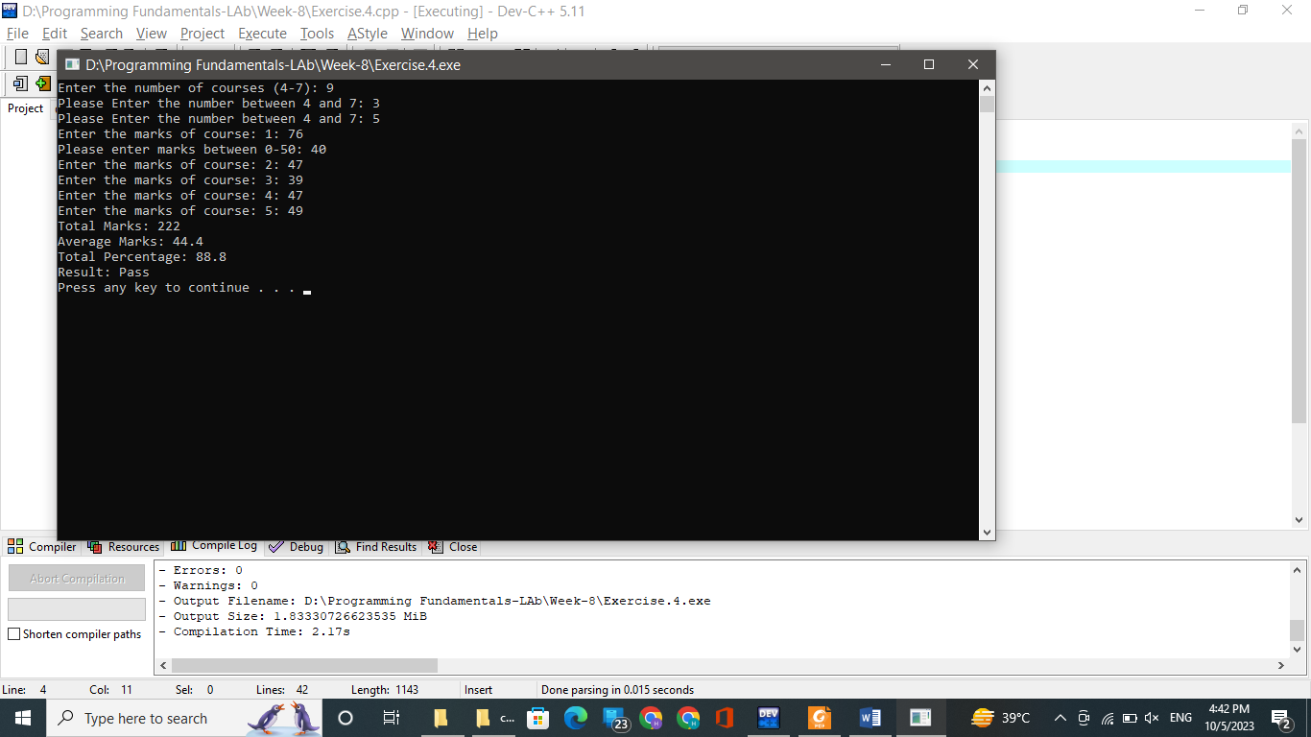

Exercise 05 (Shapes using Numbers and Characters)  
Write a program to ask user input N and design the following patterns: